**:Student Name :Roll No :Section**



# Lab No. 15



(OpenEndedLab)

Lab 15 – DatabaseApp Development in Python

Data Retrieval and Manipulation using Python

**Task#1.**

Design a database having atleast two tables using any DBMS of your own choice.

1. Dept(deptid(pk),dname)

2.Teacher(Tid(pk),name,designation,salary,deptid(fk))

3. Courses(ccode,cname,credithrs,Tid(fk))

In this lab, student will learn how to make a DatabaseApp using Python

* Create database connection

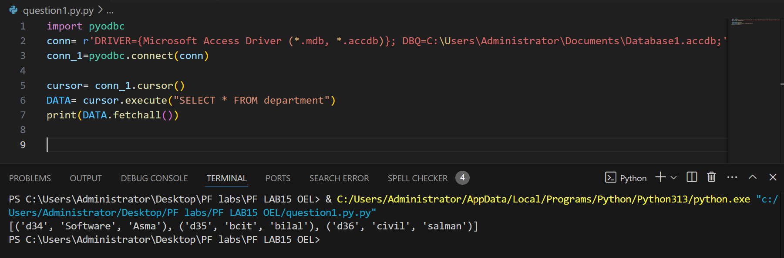

* Design GUI of your application according to your own choice using Tkinter or Custom Tkinter Module.

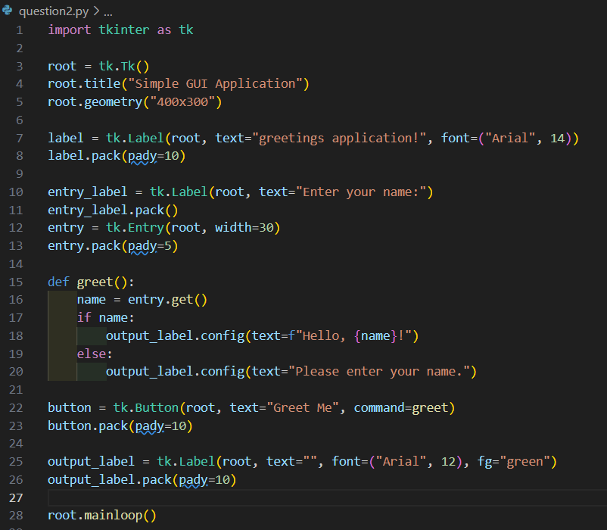

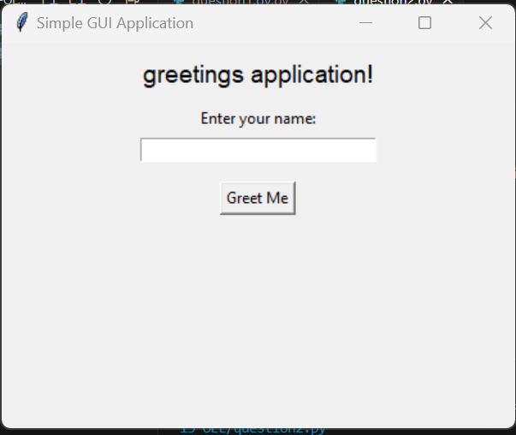

* Write Python code to display data from database into python program.



**DML (Insert& Delete)**

Task#2.

* Write a Python code to perform insert and delete operation using SQL queries on at least one table mentioned above. When user clicks on delete button ,it deletes a particular record and display a message that a record has been deleted successfully.